Summative OSCE Stations

Station 1: Nephrotic Syndrome (Minimal Change Disease)
Discipline: Paediatrics

Jeremy is a 3-year-old male. His Mother, Isabelle, took him to the park and has noticed he has had facial swelling around the eyes. She has brought him in to the Emergency Department.

- Take a history from Jeremy’s mother (7minutes)

- Answer the examiners questions (3 minutes)

Patient/Examiner Information:

Mother:
You think it could be an insect bite (but there is no rash, airway swelling or history of atopy when asked).

Everything in Hx is normal except for:
- Oedema (worse round eyes, worse in morning)
- Urine: Decreased output, bubbly.
- Less energetic compared to normal.

Examiners Questions (ask at 7 minutes)
- What are your differential diagnosis?
- What Investigations would you like to order for this patient (justify each investigation)?

Marking: Get From e-Medici

Station 2: Appendicitis
Discipline: Surgery

Station 3: OA Knee
Discipline: General Practice

Station 4: Rest

Station 5:
Discipline: Obstetrics & Gynaecology

Student Instructions:
Maria, a 28-year-old female has presented to the Emergency Department with sudden onset of severe abdominal pain in the Right Iliac Fossa.

- Take a relevant history from the patient (7 minutes)
- At 7 minutes, answer the examiners Questions (3 minutes)

Patient/Examiner Information:
Patient Script:

HOPC
Symptom: Deep Constant Right-Lower abdo pain
Onset: starting 6 hours ago suddenly
Character:
Radiation: Nil
Alleviating Factors:
Timing: Constant for 6 hours
Exacerbating Factors:
Severity: 10/10

Relevant History:
G0P0
1 year of Dyspareunia
No Hx of STI (but never been tested)

You are not trying for children now but would like to have children in the future.

Partners – Male partner (one partners for past 5 years)
Practices – Hetro vaginal
Protection – Was on COCP but stopped 4 years ago due to a DVT
Prevention – Condoms

Nil urinary of GIT symptoms

Questions from Examiner (ask at 7 minutes)
- Give 4 DDx
- What investigations would you order for this patient (do not need to justify)
- The diagnosis is Right Sided Endometrial Cyst (Endometrioma), what is the short and long term management of this condition for this patient?

Station 6
Discipline: General Practice

Kate is a 48-year-old corporate executive who has come in today to discuss the results from her health check.

The GP has asked you, a senior medical student, to review Kates results, and counsel Kate on the findings and any changes or interventions that may be needed.

In your discussion you should consider:
- Non-pharmacological/lifestyle change interventions
- Pharmacological Interventions
- Follow up advice and planning.

You have 3 minutes to review the results in reading time, then 10 minutes to counsel Kate.

(There are no questions from the examiner on this station)
(You do not need to remember the results, they will be given to you in the exam room too)

Results
Fasting BGL: 6.2 (prediabetic)
HbA1C – 6.2 (prediabetic)

Lipids (looked unhappy)
LDL – 4.8
HDL -
Total Cholesterol -

BP – 150/70
CVS Risk – Moderate

BMI – 30Kgcm3
Waist Circumference (high)
DASS10 – Moderate stress, normal for depression & anxiety
Alcohol – Consumes 5 standards a day.

Family History:
Mother: T2D
Father: AMI

Patient Script
Only if student asks – drink alcohol during day and t night to get to sleep
Diet – High processed fast foods (because you don’t have time)
Exercise – Sedentary (I have 2 kids, when do I have the time)

Station 7: Rest

Station 8:
Discipline: Psychiatry

Juan, a 55-year-old male has been brought to the Emergency Department by his wife. She stated he has had a reduced appetite for the last couple of months, has been spending more time in bed and has low motivation. In the last two days he has completely stopped eating and drinking. His GP had performed a series of test (including a colonoscopy) which all returned normal results. He is hemodynamically stable and has been given IV fluids.

- Take a psychiatric history from Juan (8 minutes)
(N.B. You are not required to perform a mental state exam)

- Answer Juan’s Question (2 minutes)

Patient/Examiner Info:
Melancholic Depression vs MDE in a 55YO M with 6/12 Hx of bereavement, low mood, anhedonia, early morning waking, low appetite. Obsession/Delusion that he was going to die of bowel cancer because brother died of gastric cancer 6/12 earlier and uncle died of bowel cancer 2 years prior. No pain/FAWN sx, no changes to bowel/bladder habits- only abdo bloating

MSE
Appearance: Weak, in hospital gown, attached to a drip
Behaviour: Slow depressed movements
Mood: Depresses
Affect: Depressed
Speech: Slow, coherent
Thought: Preoccupied with having bowel cancer (though no medical evidence to suggest)
Perception: No hallucinations
Cognition: Oriented
I
Judgement: Poor

When student probes for organic causes, give student a set of Ix results.
- All results normal (FBE, EUC, LFT, RF, Anti-CCP, HLA, ANA, TTg IgA, Anti-AGP IgG, colonoscopy)

At 8 Minutes ask the student the following question:

I am going to die anyway so can I just leave now?

If student asks:
- You are not going to eat or drink when you get home, you just want to die.
- You cannot be convinced you do not have bowel cancer.
-

Station 9
Discipline: Orthopaedic Surgery

Mary, 60-year-old female has presented with a painful right hip.

Perform a Hip examination on Mary and describe what you are doing, as well as your findings to the examiner (7 minutes)

Patient / Examiner Information:

Hip examination findings consistent with right sided osteoarthritis of the hip

At 7 minutes ask the student:
1. Based on your findings, wat are your DDx?
2. What investigations would you order (justify answers)?
3. What features of Mary’s hip XR suggest osteoarthritis?
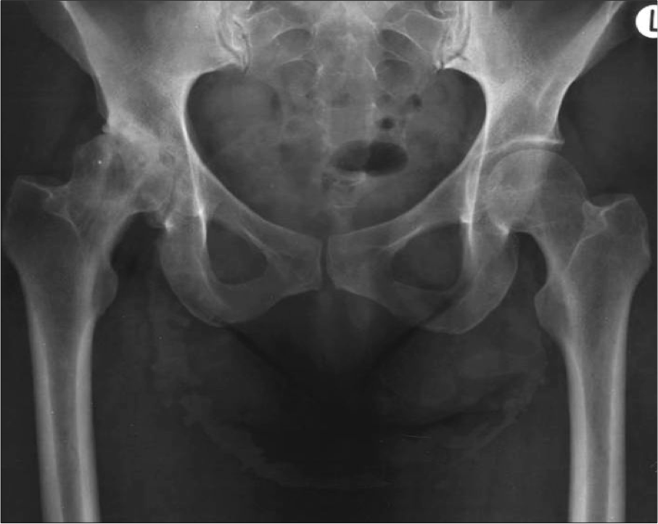

Answer to Q3:
Loss of Joint Space
Osteophytes
Subchondral Sclerosis
Subchondral Cysts

Marking Guide  Clinical competency | Failed  (0 mark) | Achieved  (1 mark) | Achieved Well  (2 marks)
Introduction, consent and hygiene  Introduces self, asks permission (consent) to proceed after brief explanation, washes hands.  Discomfort and site of pain  Confirms with the patient that they have no pain. Displays sensitivity to the patient’s needs throughout the examination. | 0 | 1 | 2
General Inspection  - Pain  - Gait/movement | 0 | 1 | 2
Hip Inspection  - Skin (colour, rash, bruise, ulcer, cellulitis)  - Contour (wasting, posture, alignment, swelling, lumps, deformity) | 0 | 1 | 2
Hip Palpation (Anterior and Posterior)  - Soft tissues (tenderness, swelling, lumps, nodes, femoral pulse)  - Bone (greater trochanter, iliac spines, SI joints, pubic tubercle) | 0 | 1 | 2
Movements  - Active (flex/extend, adduct/abduct, rotation)  - Passive (flex/extend, adduct/abduct, rotation) | 0 | 1 | 2
Leg measurement  - True (ASIS to medial malleolus)  - Apparent (xiphoid process to medial malleolus) | 0 | 1 | 2
Special Tests  - Trendelenburg  - Thomas | 0 | 1 | 2
Other Regions (Mentions)  - Musculoskeletal (Back, knee)  - Other (hernial orifices, abdomen, pelvis, other) | 0 | 1 | 2
Question 1 – What is the diagnosis and severity on the x-ray?  - Hip osteoarthritis/degeneration  - Degree (severe) | 0 | 1 | 2
Questions 2 – List 3 features of this condition seen on the x-ray  - Joint space narrowing/cartilage loss  - Subchondral cysts  - Subchondral sclerosis  - Osteophytes | 0 | 1 | 2

Global score (Overall rating of the station)

CLEAR PASS BORDERLINE CLEAR FAIL

If in doubt as to the appropriate category, also take into account the information that is emphasized and the manner/organization of its presentation.

Station 10: Rest

Station 11: Valvular Heart Disease
Discipline: Medicine

Station 12: Stroke
Discipline: Medicine

Station 13: Rest

